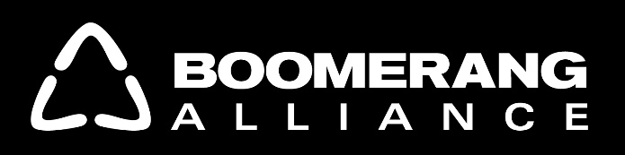

COMPARISON OF PROPOSED CDS MODELS

BOOMERANG ALLIANCE | BEVERAGE INDUSTRY
Container Deposits – a world’s best system that targets almost all container litter and achieves 80% recycling | Thirst for Good – strategies based on past failed programs that will only target 3% of container litter and minimal recycling
10cent refundable deposit – proven incentive to reduce littering | No financial incentive to change behaviour
Will virtually achieve NSW Premier’s total litter reduction target in a sustained manner by financial incentive to not litter and weekly litter collections across a wide area by hundreds of litter collectors motivated by the deposit redemption.  Divert govt and council funds to more difficult litter issues | - 100 litter collectors along highways – will miss out on other litter sites  - litter will keep recurring on highways over the weeks/months between collections.  - More bins – over 53,000 existing bins in NSW have failed to stop enough littering in the past - more will only have small impact
Charities can benefit by raising $65M per year via collections, donation directed from reverse vending machine and depot management | $1-2M/y for selected charities
Run by independent, non-profit organisation – avoids industry conflicts of interest and inefficiency | Industry has major control of the TfG program;  (their ‘’lower cost’’ CDS = limited depot/collection infrastructure)
1,500 new sustainable jobs – no impact on drink sales; + hundreds of deposit-refund litter collectors across the state | 100 part-time highway litter collectors – significant occupational dangers
$18.5M/y net financial benefit to local councils – likely waste charge reductions | One litter collection cage for every council
Convenience for consumers via 500-800 reverse vending machines across the state | 100 reverse vending machines with corporate advertising and non-financial prize for the returns – similar overseas programs have failed to collect sufficient containers and shut down
Cost effective clean up program – significantly cheaper per container than current programs | Likely to be expensive for limited litter collection
No government or industry subsidy – CD scheme is financially self-sustaining litter and recycling gains are long term | Dependent on industry subsidy and management – support likely to be reduced over time once threat of regulation diminishes
Education program – extensive advertising about CDS, financial incentive and how to use it and change behaviour | Community education about Thirst for Good – minimal impact on behavior as advertising loses traction

www.boomerangalliance.org.au
February 2016

